UW Grand Challenges Impact Lab 2019
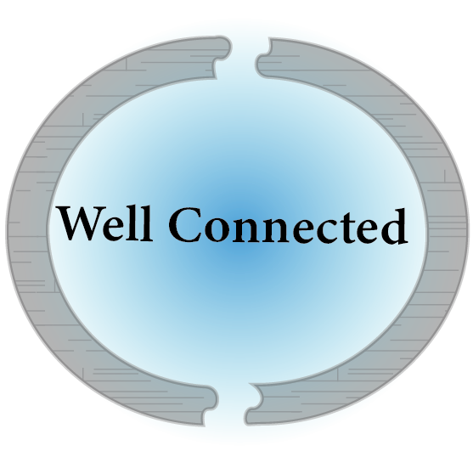

Bujin Bekbulat, Evan Lester, Cristina Lopez, Hendrik Ufkes

Table of Contents
Vision 3
Problem 3
Customers 4
solution 5
make it real 7
citation 8
appendix 10

Vision

We are Well Connected. Our goal is to raise the water table across Bangalore and create a water secure city. We attempt to do this by turning to the overlooked Manuvaddars, traditional well diggers. They offer open recharge wells, a modern modification to a traditional technology which can raise the water table. These individuals must have an elevated platform to reach a greater customer base so their valuable services can become common practice.
Problem
Bangalore has gone through a period of immense population growth. Between 2011 and 2018 the population rose from 9.62 million to 12.0 million (1). Such astronomical growth has put immense pressure on resources of all kinds, and particularly strained the amount of water which is available. The story is told by the water table. Decreasing from 10-12 meters to 76-91 meters in the last two decades, the changing water table has created a shift in technology (2). Shallow open wells have become far less popular as they yield less water, while the private deep borewell technology has been more reliable. Currently in Bangalore there are 80,000 private borewells registered in the city, but there are closer to 400,000 wells in total (3). These people are taking matters into their own hands because the Bangalore Water Supply and Sanitation Board (BWSSB) has failed to supply all its citizens with water (4). The immense number of borewells has depleted the groundwater even more and new borewells have to drill deeper, more than 1000 feet in some instances, without any guarantee that they will yield water.

The water table is decreasing unevenly across the city, so people are impacted differently based on their location. Most impacted are those on the outskirts of Bangalore with a lack of connections to the government water supply. They rely on deep borewell technology, and thus the depth of the water is directly proportional to their supply. Figure 1 depicts the water table of Bangalore in 2016. It is clear that the outskirts are a lighter color, pointing to a lower water table in these regions. Such a pattern is indicative of greater ground water use in these areas.
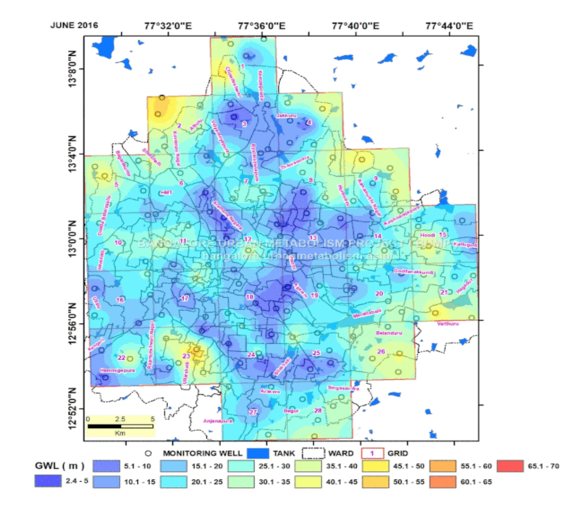
Figure 1. Displays the depth of the water table across Bangalore based on observation wells scattered across the city (5)

An additional facet to this problem involves traditional well diggers or Manuvaddars. For generations they have held the occupation of digging shallow open wells across Bangalore. However, as the water table across Bangalore declines, shallow dug wells have become steadily less common (6).
These individuals, who typically earn a lower income and are less respected members of society (given their traditional caste rolls) rely primarily on this vanishing work. We have spoken with 14 well diggers and they have all stressed their personal struggle. They go months at a time without work and have to find jobs by surveying communities in the city on foot. This is despite the fact that the open wells they dig can be retrofitted with rainwater systems, creating recharge mechanisms. They allow water that would runoff to percolate into the ground; something which could increase Bangalore’s water security. With an increase in open wells Bangalore might be able to solve much of its issues regarding its decreasing water table.

This issue of water table depletion, stems ultimately from the basic water culture of the last century. People find a water source, use it, deplete it, and move on to the next one. Very little thought is given to how to make a single source sustainable; water is looked at as an infinite resource (7). Evidence for this theory is rampant historically across the world. However, in Bangalore this behavior is suggested by the 25 new borewell drilling applications the BWSSB gets every week (8). This has led to people digging deeper to find more water instead of attempting to recharge areas that they have depleted. Worsening the water crisis, 78% of the surface area of Bangalore is paved, with further development carried out each day (9). This concretization causes more loss of water; it is estimated that only 20% of the rainwater actually reaches the aquifers (10). Ultimately, the attitude towards water and concretization are causing groundwater scarcity in Bangalore.
Customers
Our proposition to these intertwining issues of water scarcity is a website platform, Well Connected. Well Connected has two groups of customers, both of whom are also beneficiaries. Our primary customer is middle to upper income homeowners on the outskirts of Bangalore. They will benefit from our services by gaining water security for a fair market price. Our secondary customer is the well diggers who we will market and provide increased business for.

Homeowners in this area of India face a reducing ground water table as a result of the aforementioned borewell overuse as well as the concretization which accompanies urbanization. In their everyday lives these people do not want to think about the source of their water. As with everyone, these homeowners are busy; they want to turn on their tap and receive water. A survey by the The Institute for Social and Economic change (ISEC) in 2013 suggested, 56% of people neglected to install rainwater systems because they simply could not fit it into their schedule (11). Without the time to devote to research sustainable water processes they turn to the simple, tried and true solution.

Following the historical trends, they find a new water source by drilling deeper or getting more expensive water from outside tankers. There are 100-120 active tanker companies in the Bangalore, indicative of a marketplace that is large enough to support this massive competition (2). As evidenced by a visit to a gated community, the management of these communities takes care of the entire water needs for the homeowners; they do not have to think about these water sources unless the situation becomes dire. An individual homeowner will have to face this problem more directly. Borewell technology has the perception of cleanliness and an abundance in the marketplace, it feels to the customer like the correct solution (12). This only worsens the overall situation of the groundwater. Additionally, with such a drastically reduced water table, borewells actually are the only option for many people in the dry season.

As for the well diggers who combat the dropping water table, they struggle finding work and marketing themselves. In speaking to the NGO Biome Environmental trust, they claimed this stems from a lack of education, confidence, and business acumen. This was confirmed by our previously mentioned interviews with these workers. They simply do not have the tools to maintain a steady business stream. Given the value of their work to the water table, well diggers struggling for work are a wasted potential.

In conducting interviews, we have spoken to 5 gated community managers, all of whom admit concern over lower yields in borewells. We also spoke to a few apartment dwellers who have run out of water from their borewell. The reducing water table is clearly impacting their lives. On the other hand, citizens that are supplied water by the Cauvery river and are closer to the center of the city are not as concerned about the issue. Yet, there are statistics which suggest that 300 borewells across Bangalore dry up in a month (13). As this pattern continues, more individuals are forced to look for alternative sources of water, and thus, confront the issue of groundwater depletion. The issue is rising to the forefronts of people’s minds.

The government attempted to solve this issue by putting a requirement of groundwater recharge systems into law in 2009. Unfortunately, this mandate lacks enforcement. 59,000 of houses required to have not implemented required rainwater systems, let alone the additional recharge well (14). While policy can be effective, this mandate has not been. The aforementioned survey by ISEC supports this sentiment. When individuals feel overwhelmed about the complexities of water resources but are not given guidance, they simply do not change their behavior. They stick to what they know, which is drilling deeper borewells are buying more tanker water.

Solution
The website Well Connected is proposing connects customers to Manuvaddars. It functions as a place where customers can go and select the type of project they want (whether that be rainwater harvesting, an open well dug, a combination, or just maintenance). From there they will fill out a quick form describing the desired project. Then a Manuvaddar will be given the information from the form by an intermediary party. Which well diggers receive information about certain customers will be based on their availability and proximity to the job location. From there, the customer will receive a call from interested Manuvaddars and when one calls with a price and convincing pitch they will be highered. This will increase the amount of work for Manuvaddars, and allow the customers to have a simple connective tool that they can access at anytime they need a job done. Average Price points will be posted on this website and should help customers ensure they are getting a fair deal. Actual price points will depend on the specifics of a project such as roof and well size. We would act as an intermediating party and ensure each individual is getting treated fairly in terms of payments and work completion.
The theory of change for this project is multifaceted. We plan to reach our overarching goal of raising the ground water table in Bangalore with a slowly built network of open wells. Through marketing the service of open wells and rainwater harvesting to customers who are on the outskirts of Bangalore (where the water table is lower) we hope to raise awareness about this solution to their water needs. With consumers having an avenue to easily coordinate with the well digging contractors, we expect more wells to be purchased and dug. As a result, the water table will begin to be replenished as each well is directing more rainwater that would otherwise flow from the city, into the ground.
There is solid evidence that open wells have the capacity to recharge ground water in areas of water stress. A report completed in southern Mali studied the installation of 484 shallow wells and any change in water levels during the drought season before and after (15). The shallow wells appeared to help rejuvenate the water table. The ultimate conclusion was that in the rainy season shallow wells can recharge the aquifer successfully. This allows for a nearly stable groundwater level in the dry season, allowing borewells to remain functioning (15). However, this is not the same soil or weather as Bangalore, so specific cases are needed to prove worth in this area. Bangalore’s Rainbow Drive community used to rely on Borewell water until groundwater depletion became a major threat in 2006. In a slow effort to comply with increasingly strict regulations on borewells, the community’s own constrictions, laws requiring both rainwater harvesting and recharge wells, this community began to install recharge wells (15). Today they have 350 wells which have rainwater recharge systems. They have raised the water levels in the shallow aquifers effectively, recharging shallower withdrawal wells (16).
In addition to this, there is evidence that shallow wells can rehabilitate borewells. In the community of Malleswaram in Bangalore, a large well that was 60 feet deep was restored and connected to four sumps. Diverting rainwater to the large well appears to have caused two out of four of the nearby borewells have been restored (17).
Additional evidence needs to be provided, however, that the marketing portion of our intervention would be successful. E-commerce is growing 51% per year in India; that is the highest in the world (18). This is what indicates to us that the website platform is promising. However, evidence that customers can be interested in the proposed solution is needed. We have begun door to door marketing to attempt to generate website traffic, and spoken to individuals facing water issues in the city. A genuine interest seems to exist. A woman in a gated community, MS Ramaiah city, who we spoke with offered to pitch the idea to president of the residency association. This community has about 450 houses and is a massive opportunity. Another family in an apartment expressed interest in pitching the idea to its other residents of the building. While these individuals have expressed interest in our services, we have yet to convince those who have a more secure water supply, even if it is supplied by unsustainable practices. Understanding this, we have decided to have both a marketing and an educational side to our company. Both sides are present on different pages of our website and we have tested them by going door to door to attract interest.
To sustain ourselves financially we will charge a 10% commission fee to the well diggers. This is for the service provided by connecting the well diggers to more customers. When we start up our company, we will need two positions: a marketer and someone for logistical coordination of the well diggers. This means that there are two salaries that need to be accounted for in our expenses. If we discount the need for an office space, as marketing and this logistic coordination can be done at home and do not consider the initial costs to start a business in the city, these are the normal overhead for a month. These salaries are about 35,000 rupees per month for a marketing employee and about 40,000 rupees per month for a logistics manager, both numbers for India (19-20). With these expenses we would need to sell 750,000 worth of wells at a minimum which at an average well cost of 30,000 (based on data compiled and shown to us by Biome pictured in the appendix), works out to a minimum of 25 wells services sold in a month. Assuming there are other unaccounted for expenses which will inevitably occur, we will move this to 30 wells as a precaution. We think that initially this figure will be hard to make but given time and increased well diggers in our network we will be able to do this successfully.
Make it real
Primary data was collected from 16 potential customers including homeowners, gated community managers and apartment residents. Inquiries were made into their water sources and the presence of open wells or rain water systems. In general, from this data, it appeared that the main sources of water were the Cauvery river and borewells. The presence of rainwater systems was fairly prevalent but in no greater than 40% of the households and communities. This sample was likely influenced by where we took it, primarily in Cox town near Benson town and on the outlimits of the city near White Center.
Additionally, we talked to 14 well diggers to confirm their struggle in getting employment. All of these well diggers discussed the lack of work and difficulty connecting to customers. Only 2 of these individuals expressed relative confidence in their marketing skills.
Both these data sets helped us confirm issues expressed to us both in research and in discussions with Biome.
Our minimum viable product was the construction of a website. This website is very basic, but it functions by allowing the individual to choose a project and fill out a survey about the project. From there we can connect the user to a well digger. These individuals also have profiles on the website, so the users can get to know them. To receive feedback, we have put a form on the website which fills out a few basic questions. This has been sent out to students in our program but also on flyers to some of the residents in Bangalore. So far, we have had 18 responses and are working on processing feedback to include valuable insights to our website.
For the next step we plan on continuing to test the interest in our product by expanding our outreach. We have created another website which draws on a children’s book meant for educating about basic water issues, with the hope that this knowledge will transfer to parents. Additionally, our website features an animated video describing the process of recharging aquifers. This approach along with a fuller marketing campaign is our clear next step. Additionally, we have 14 well diggers on the site but the community is far larger, and we hope to interview more workers, getting as many as we can on this site so our platform can expand. As we take these steps, we will be testing the validity and interest of the projects which we are performing further. We hope to achieve a few successful cases of well installation, and from there we can look at hiring people for a more permanent company.
As previously mentioned these people who we need to bring onto the team are a permanent marketing professional and a logistic coordinator. From there, if we can generate enough product, our website can be revamped and updated by a professional software designer. With these steps we can further professionalize our service and look into the creation of an application.

Citation
- “Bangalore (Bengaluru) District : Census 2011-2019 data,” Religion Data - Population of Hindu / Muslim / Sikh / Christian - Census 2011 India. [Online]. Available: https://www.census2011.co.in/census/district/242-bangalore.html. [Accessed: 23-Feb-2019].
- “Bengaluru: The Water-Waste Portrait,” Centre for Science and Environment, 2011.
- A. R. Shivakumar, “Sustainable Water Supply Strategy for Bangalore - A Model for Emerging Cities in India,” International Journal of Science, Technology and Society, vol. 6, no. 1, p. 6, 2018.
- K. Raj, Where All the Water Has Gone? An Analysis of Unreliable Water Supply in Bangalore City. Bangalore, working paper, 2013.
- G. Wang, “Menu,” Bangalore Urban Metabolism Project BUMP, 23-Oct-2017. [Online]. Available: http://bangalore.urbanmetabolism.asia/2017/10/23/groundwater-table-maps/. [Accessed: 15-Mar-2019].
- Farooqi, M. “Groundwater Management in Bangalore — Impact of Municipal Waste Disposal Practices on Groundwater Quality.” Journal of the Geological Society of India, vol. 78, no. 5, 2011, pp. 488–489.
- Hani, Dr & Abu-Qudais, Hani. (2003). Water Demand Management—Security for the MENA Region.
- TNN, “Board gets 25 drilling applications a week - Times of India,” The Times of India, 19-Apr-2017. [Online]. Available: https://timesofindia.indiatimes.com/city/bengaluru/board-gets-25-drilling-applications-a-week/articleshow/58252387.cms. [Accessed: 15-Mar-2019].
- T. Ramachandra, V. S., B. Airhal, “Frequient Floods in Bangalore: Causes and Remedial Measures”, Indian Insitute of Science, Aug-2017. [Online]. Available: http://wgbis.ces.iisc.ernet.in/energy/water/paper/ETR123/contents.html
- D. Shekhar, “Rains are here but concrete surfaces block harvest efforts,” The Economic Times, 29-May-2018. [Online]. Available: https://economictimes.indiatimes.com/news/politics-and-nation/rains-are-here-but-concrete-surfaces-block-harvest-efforts/articleshow/64364620.cms?from=mdr. [Accessed: 15-Mar-2019].
- K. S. Umamani and S Manasi, Rainwater Harvesting Initiative in Bangalore City: Problems and Prospects. Bangalore, working paper, 2013.
- “Borewells,” Urban Waters, Bengaluru. [Online]. Available: http://bengaluru.urbanwaters.in/borewells-97. [Accessed: 15-Mar-2019].
- S. Basu, “Bengaluru water utility to launch door-to-door drive to ...,” Down To Earth, 04-Jul-2015. [Online]. Available: https://www.downtoearth.org.in/news/bengaluru-water-utility-to-launch-doortodoor-drive-to-check-illegal-borewells-40731. [Accessed: 15-Mar-2019].
- G. BR, “Bengaluru slips up on rainwater harvesting: Despite being mandatory, 59,000 structures yet to have the facility installed,” Bangalore Mirror, 03-Jul-2018. [Online]. Available: https://bangaloremirror.indiatimes.com/bangalore/civic/bengaluru-slips-up-on-rainwater-harvesting-despite-being-mandatory-59000-structures-yet-to-have-the-facility-installed/articleshow/64846543.cms. [Accessed: 23-Feb-2019].
- B. Z. Birhanu and R. Tabo, “Shallow wells, the untapped resource with a potential to improve agriculture and food security in southern Mali,” SpringerLink, 30-Apr-2016. [Online]. Available: https://link.springer.com/article/10.1186/s40066-016-0054-8. [Accessed: 15-Mar-2019].
- “A community practices integrated water resources management,” Urban Waters, Bengaluru. [Online]. Available: http://bengaluru.urbanwaters.in/case-study-integrated-water-resources-management-322. [Accessed: 15-Mar-2019].
- AR Shivakurnar “No more Dry Speels at Dhobi Ghat.” Deccan Herald. 09-Jan-2012. [Online]. Avialable: http://www.kscst.iisc.ernet.in/rwh_files/rwh_dh_publications/22%20No%20more%20dry%20spells%20at%20dhobi%20ghat%2009.01.12.pdf [Accessed: 15-Mar-2019].
- “E-commerice Industry in India” India Brand Equity Foundation. [Online]. Available: https://www.ibef.org/industry/ecommerce.aspx. [Accessed: 15-Mar-2019].
- “Salary: Logistics Manager in India,” Glassdoor. [Online]. Available: https://www.glassdoor.co.in/Salaries/india-logistics-manager-salary-SRCH_IL.0,5_IN115_KO6,23.htm?countryRedirect=true. [Accessed: 15-Mar-2019].
- “Salary: Marketing in India,” Glassdoor. [Online]. Available: https://www.glassdoor.co.in/Salaries/india-marketing-salary-SRCH_IL.0,5_IN115_KO6,15.htm. [Accessed: 15-Mar-2019].
- Groundwater, Self-Supply and Poor Urban Dwellers: A Review with Case Studies of Bangalore and Lusaka. International Institute for Environment and Development.
- L. V. Sunish, “Bengaluru's borewells, who's counting? |,” Citizen Matters, Bengaluru, 29-Jan-2019. [Online]. Available: http://bengaluru.citizenmatters.in/4179-depleting-groundwater-whos-responsible-4179. [Accessed: 15-Mar-2019].
- M. K, “Should Bengalureans be grateful for BWSSB's water rates? |,” Citizen Matters, Bengaluru, 14-Dec-2017. [Online]. Available: http://bengaluru.citizenmatters.in/should-bengalureans-be-grateful-for-bwssb-s-water-rates-6907. [Accessed: 15-Mar-2019].

appendix

Randomized Control Trial

Ideally for the Well Connected would select two neighborhoods in Bangalore. Ideally these neighborhoods would be in areas that have a similar water table depth (this could be measured by observation wells). Additionally, borewells with similar depths would be sought out. Both of these neighborhoods would have need to have dry borewells. Open wells connected to rainwater harvesting or other runoff diverting systems would be installed about 60% of the households in one community. The other neighborhood (control) would receive no such intervention and would cary on the receiving water as normal. While it would be ideal to have both have borewells so the ability of these wells to recharge the bore wells can be tested, what is more important is that water is given to these neighborhoods from a consistent source that is the same over the time scale. At the end of a rainy season and at the end of the dry the water depth of both neighborhoods is measured (from observation wells). This would indicate the effectiveness and impact of the intervention at raising water in the shallow aquifer. Additional extension of this trail to 5 years, with the observation wells measuring water levels every rainy and dry season could be more helpful to establish a time scale for this intervention.

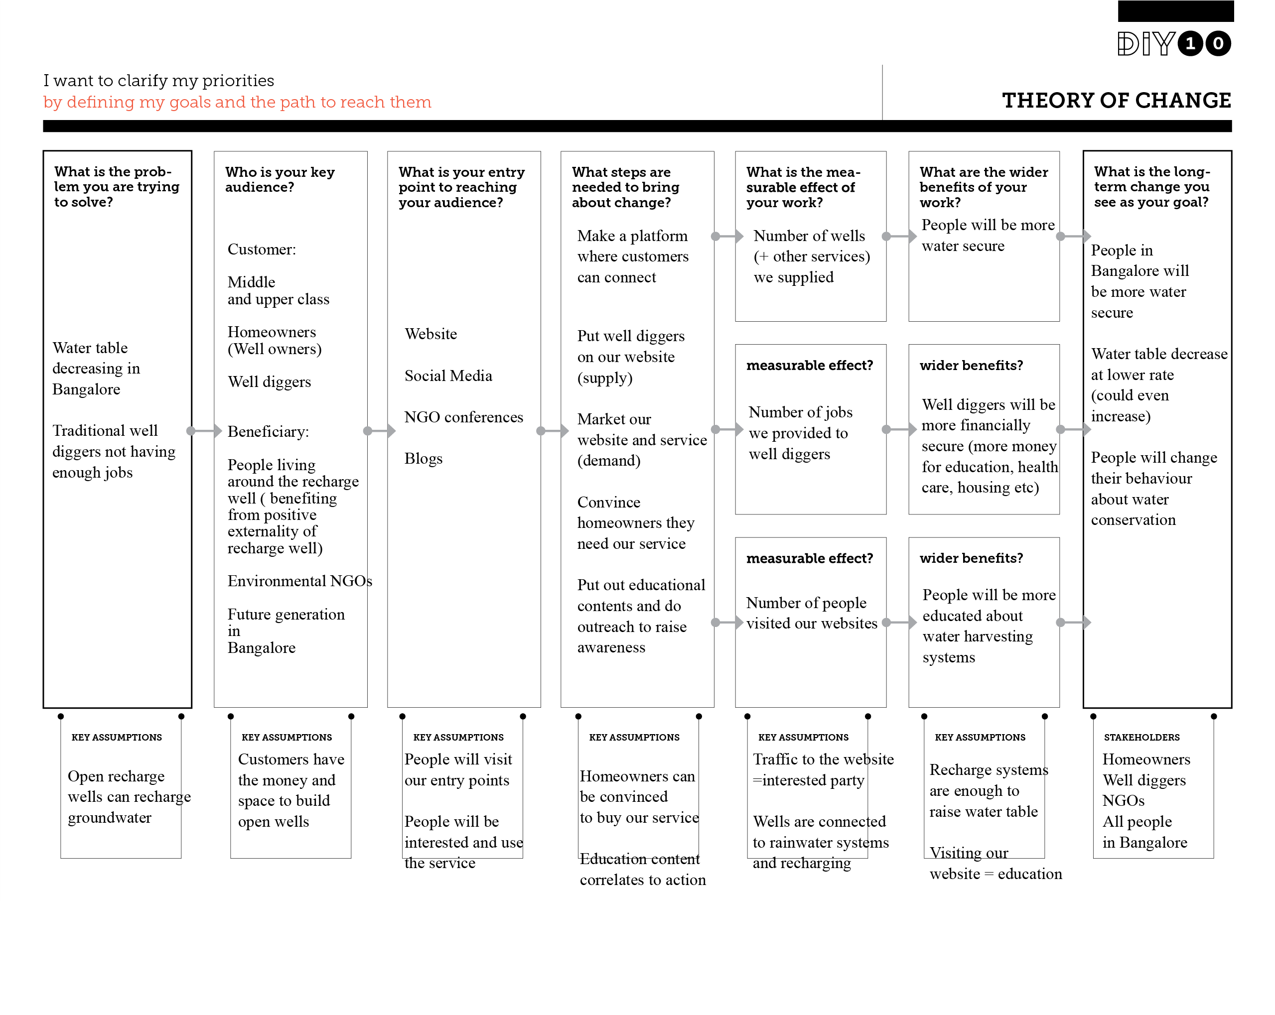

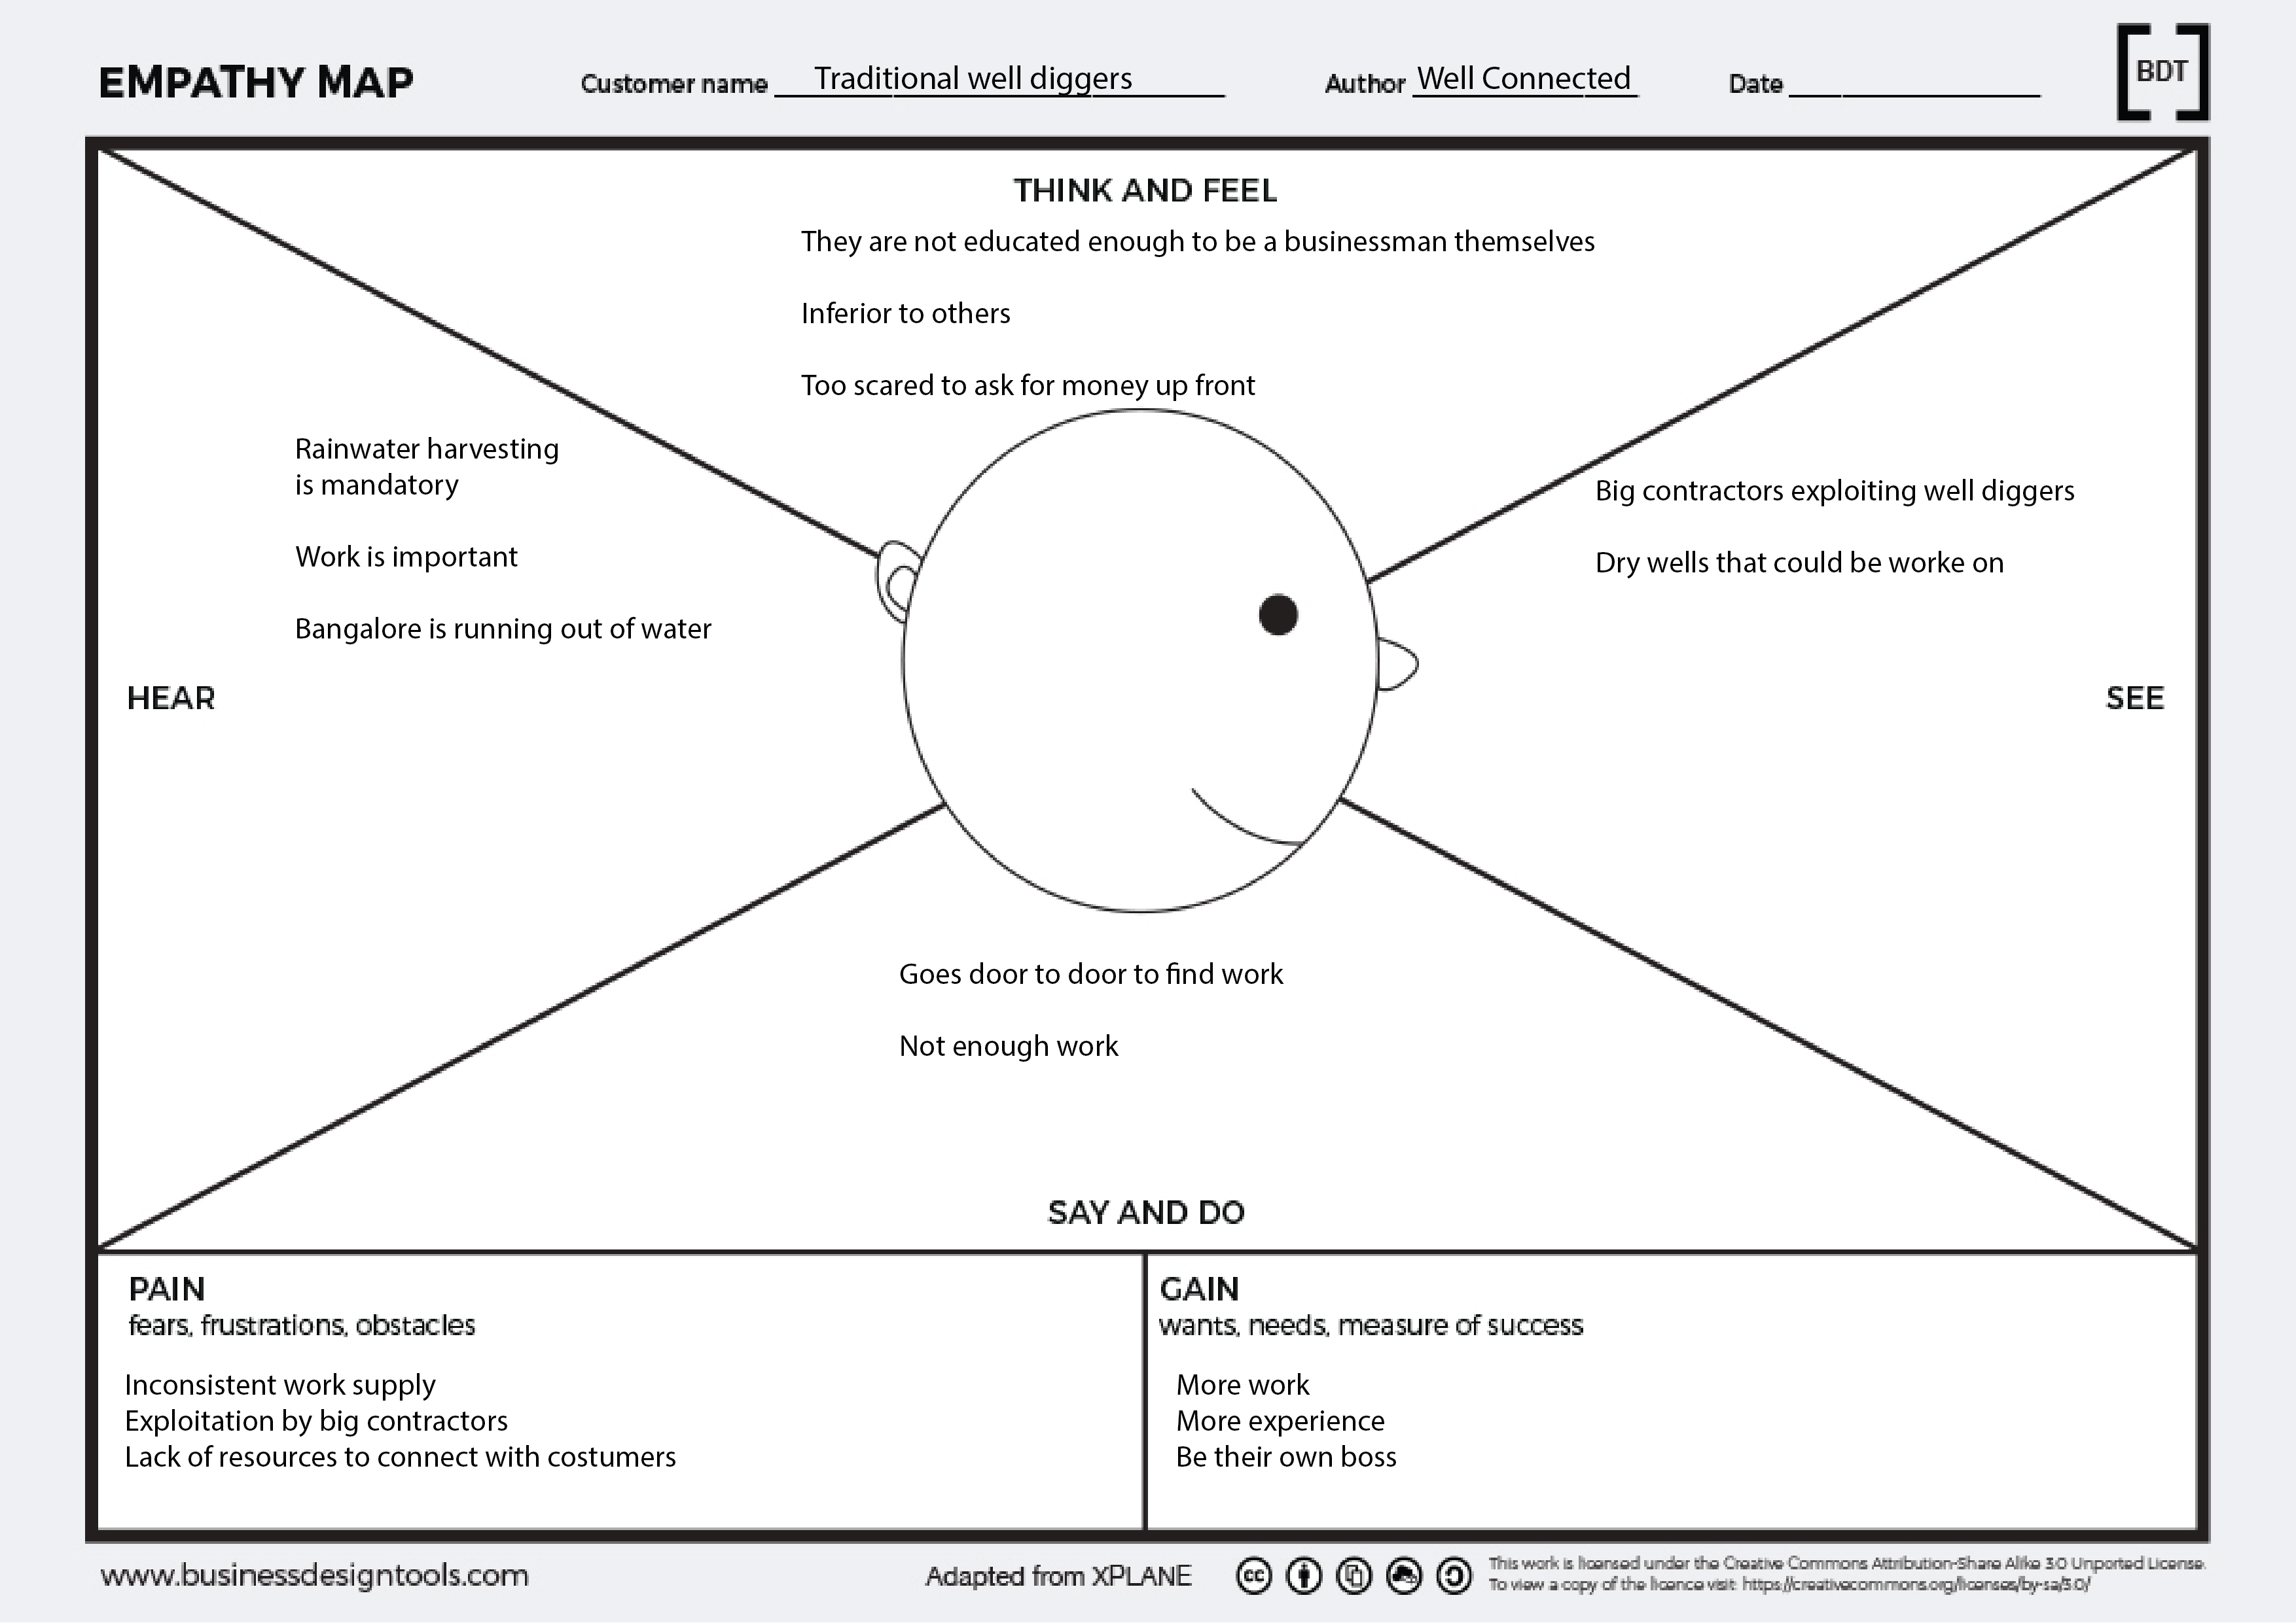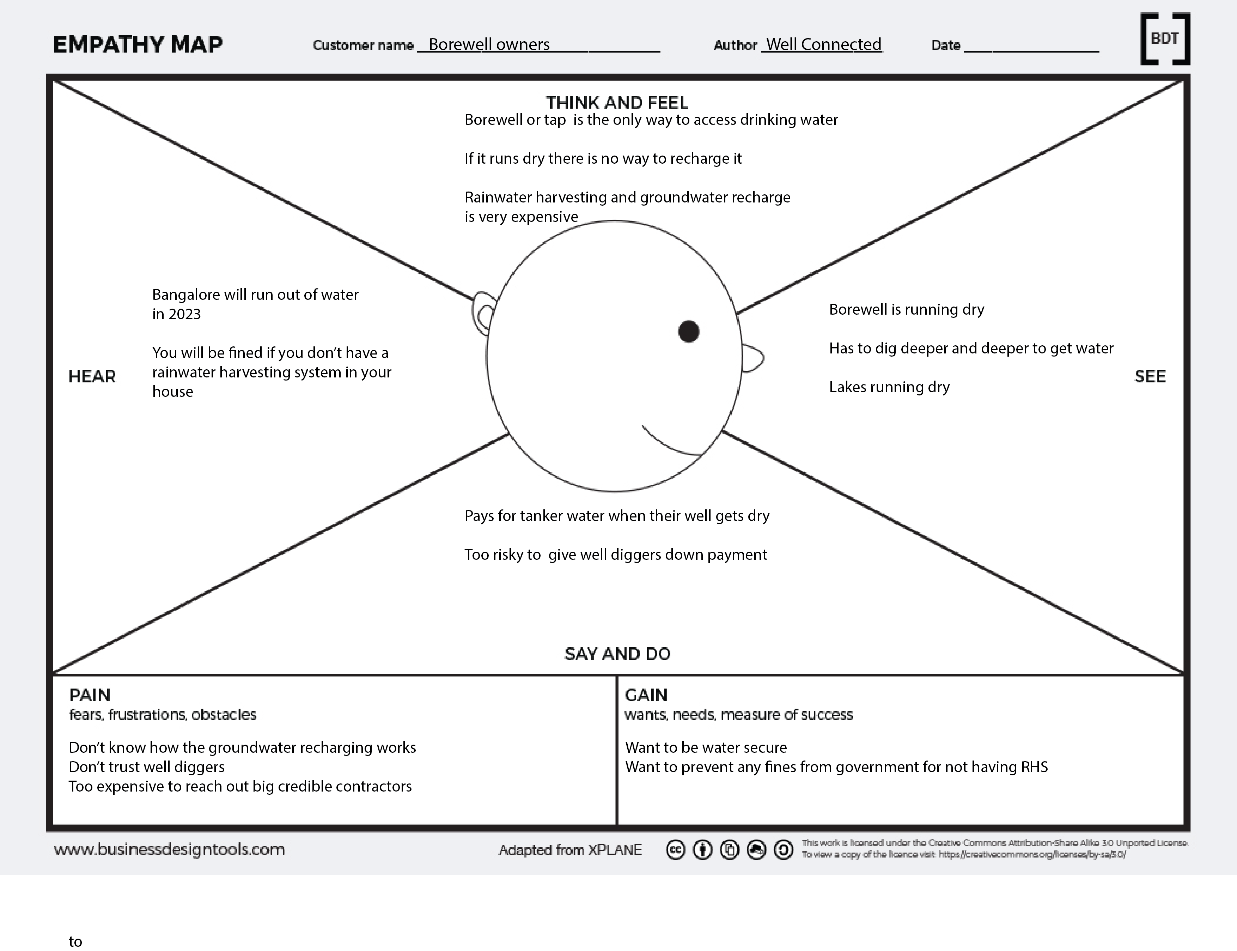

Main Prototype: https://sites.google.com/view/wellconnected
We created a website for our prototype. In getting feedback from a google form we were able to test the aesthetics and information presented in our website. To test the appeal of our product to customers we canvassed a few neighborhoods and spoke with a few interested parties. However, the hard copy prototype is the website. Screenshots of a few of the pages are attached but I would recommend a visit to the site and to fill out the feedback form to help it improve.

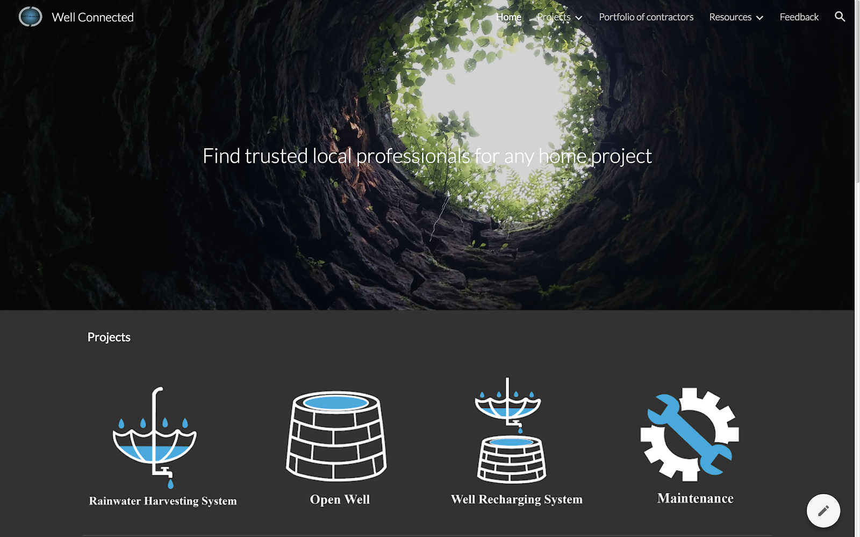
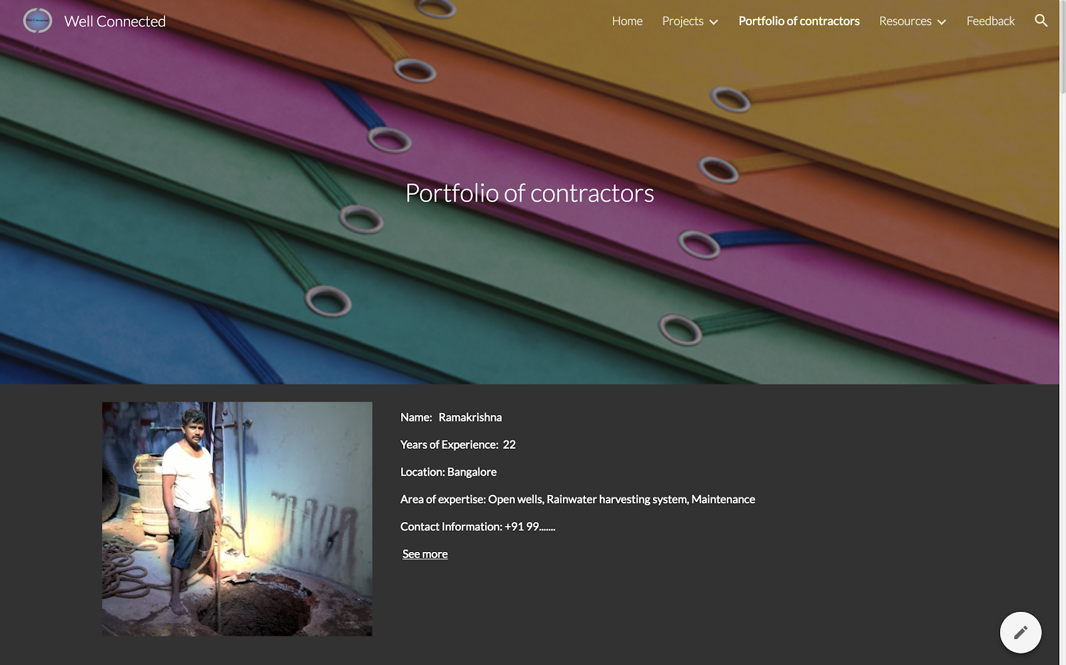
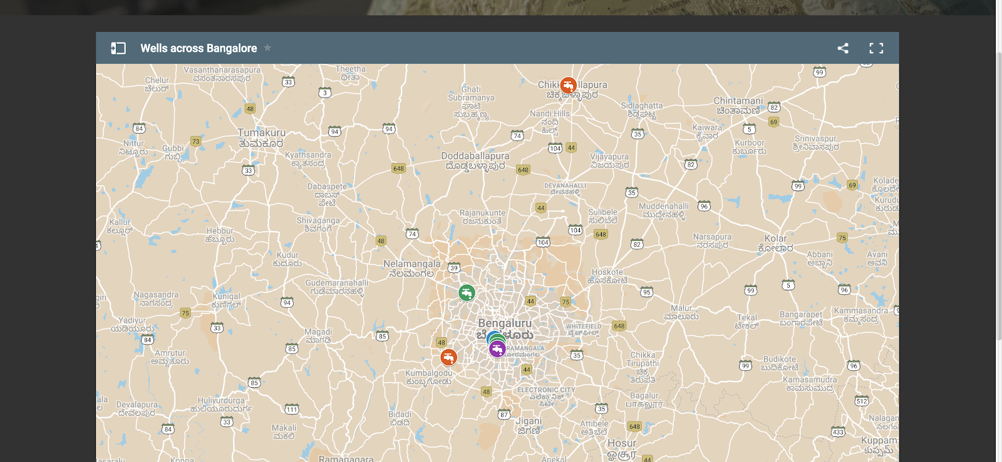
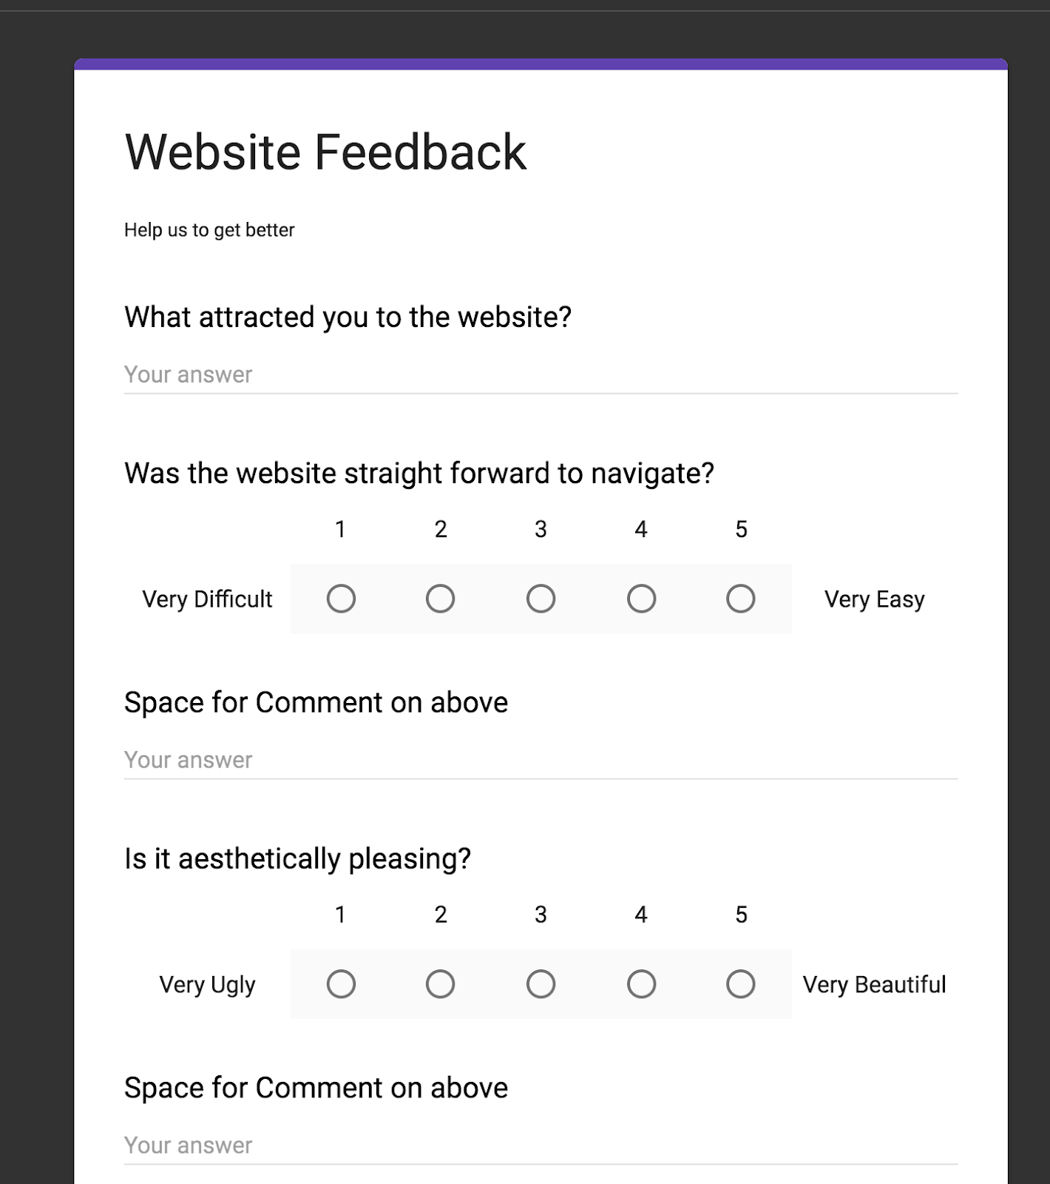

Secondary: https://sites.google.com/view/mayaconnected
This is our second website. The website has not been tested but the children’s book has been. . 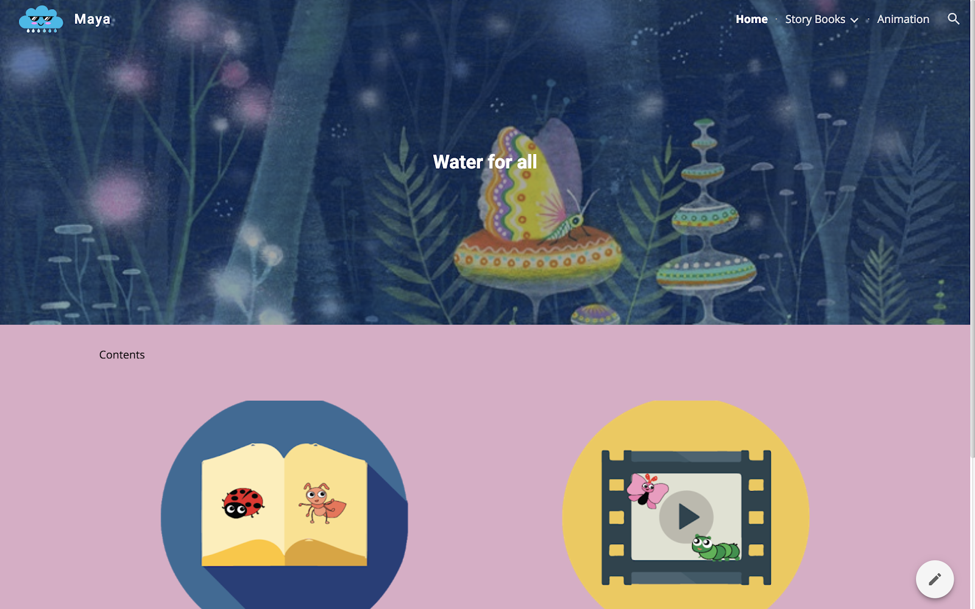
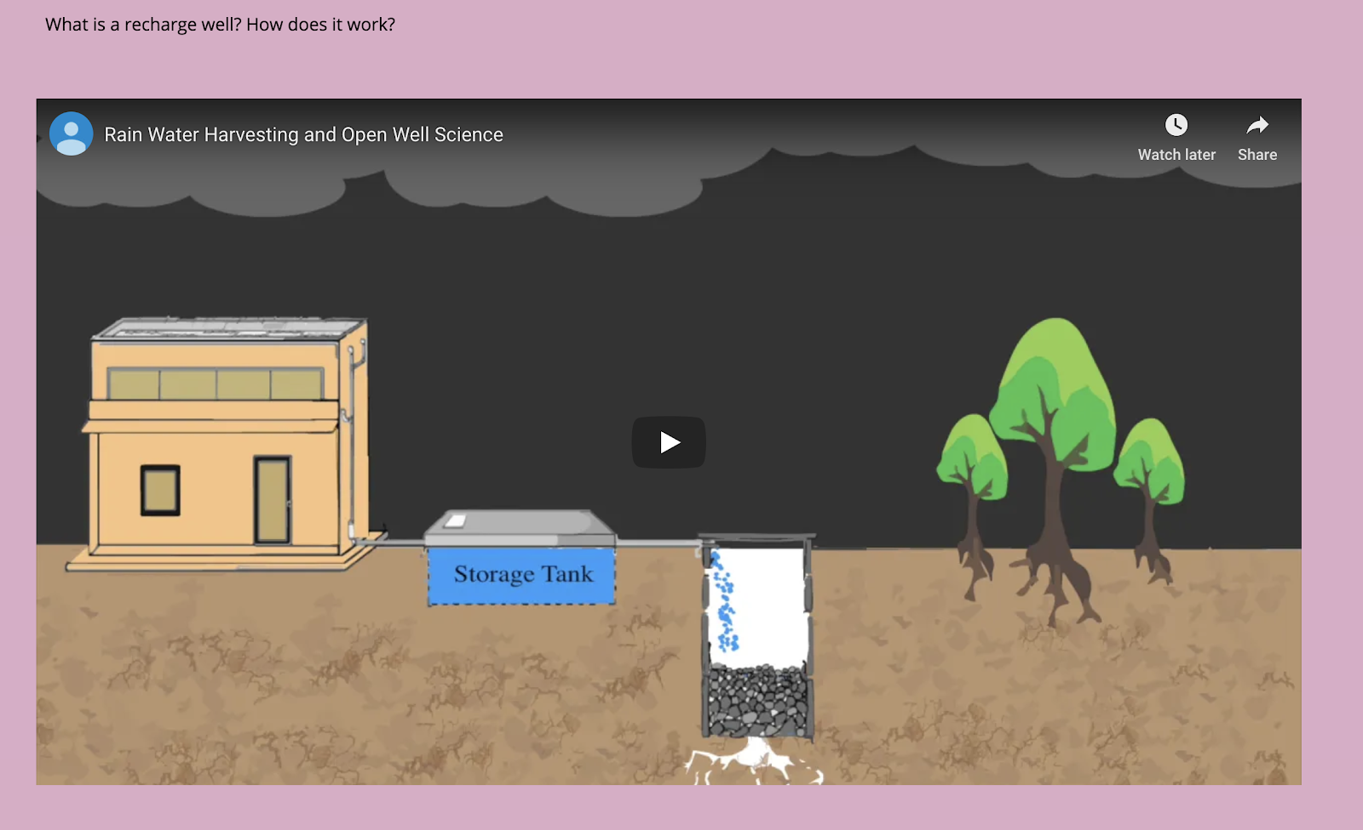

Feedback:
This was provided by google forms on the website. By canvassing neighborhoods and sending surveys out to the student body of GCIL we gathered about 18 form surveys and 2 email suggestions for our website. The results were generally quite positive. Most people really liked the design and layout of the website. In general there was some confusion about finding the costs which we provided on the website. Furthermore, it seems that people are excited to learn more both about the work these people do but also have a greater understanding of the context of these projects. We are currently attempting to incorporate the feedback we have found most valuable. Unfortunately, we have not had time to make any changes. Most of these changes though are fairly simple and would not take too much to add. 93.3% of people said they learned something from this site, that was the most encouraging piece of feedback. We also showed the website to Biome and got feedback about our general business model.

